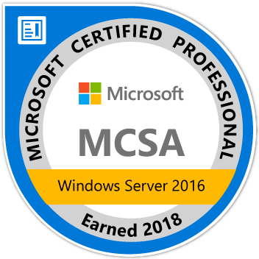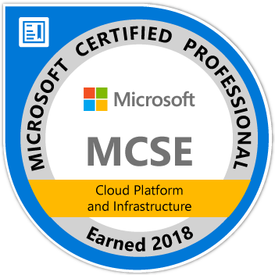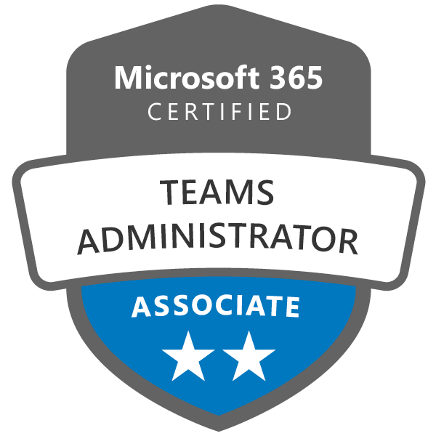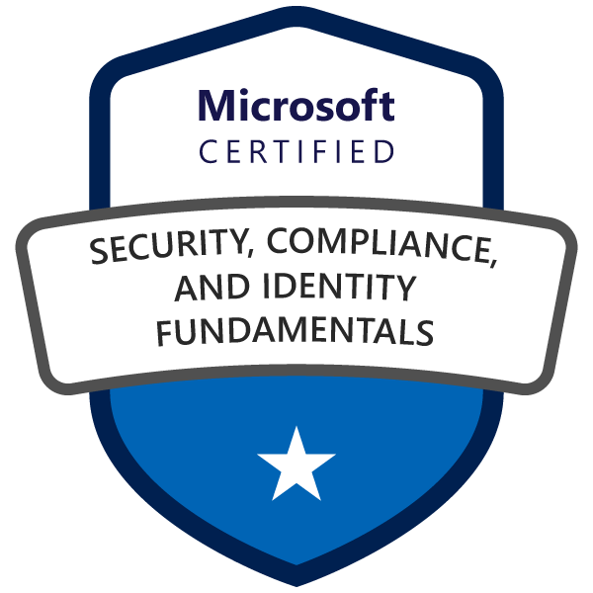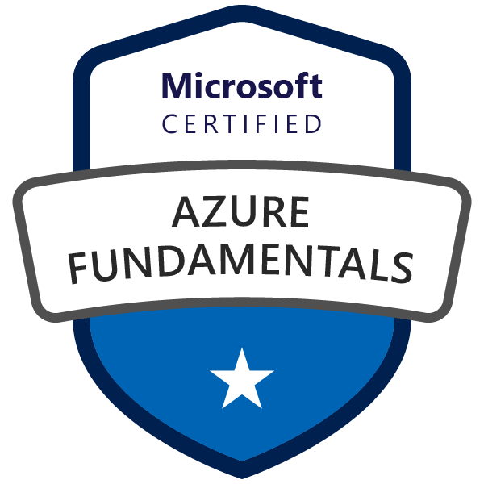

ROBIN POULOSE
VAZHAPADAVIL HOUSE
MANATHANA PO
MADAPURACHAL
KANNUR DISTRICT
KERALA
Mobile No: +91-9744244869
Email Id: info@robz.pro
Website: robinpoulose.com
LinkedIn: https://www.linkedin.com/in/robinpoulose/

PROFESSIONAL PROFILE
Windows Support Engineer with above 5 years of hands-on experience in Windows Server, Office 365, and Azure administration. Providing L2 support to the clients in Windows platforms. Have expertise in Windows Administration. Proven ability in handling various IT related requirements and challenges and leadership qualities.
CAREER HIGHLIGHTS
  - Experience with IT infrastructure servers and other devices including Windows servers, Azure, Office 365, other networking devices.
  - Experience in deploying and maintain MS Technologies such as Windows Server, Active Directory, Exchange Server, especially in Intune, and Office 365.
  - Experience in Installation of AD and Exchange servers. Handled various migration of AD Domain, Exchange server, office 365 migrations, and Azure VM migrations.
  - Managing IT Infrastructure using remote management tools like Solar Winds N-central, Screen Connect, Barracuda MSP, Team Viewer, Any Desk etc.
  - Working on the L3 level support in Windows administration and supporting the team for L1, and L2 fault-resolution
  - Strong, demonstrated customer service/support skill.

PROFESSIONAL CERTIFICATION AND TRAINING
- Microsoft Certified Solutions Expert –MCSE and server virtualization with windows server Hyper-V and system center specialist (MCID: 11397883).
- Certified for MS – 700, AZ -900, CS -900
- Course completed in CITCA - Certified IT & Cloud Architect from CMS Info system PVT Kannur.
- Completed the course of Microsoft Certified Solutions Expert (MCSE Windows 2012) AND RHCE from CMS Info system PVT Kannur.
- Successfully completed the course of CCNA AND ITIL from CMS Info system PVT Kannur.
PROFESSIONAL EXPERIENCE:
Organization : EYNE TECH SERVICES PVT. LTD.
Period : 9th July 2020 to till the date.
Designation : System Engineer L3.
Location : Infopark Kochi.

Organization : NBTC
Period : 21st December 2018 to 8th July 2020.
Designation : Technical Support Engineer.
Location : NBTC Kochi.

Organization : Wipro InfoTech. (Under payroll of Skypro Technologies)
Period : 2nd March 2016 to 20th December 2018.
Designation : Desktop Engineer L2.
Location : EXL Service PVT, Info Park Kochi.
ROLES AND RESPONSIBILITY
  - Good expertise in deploying and maintain MS Technologies such as Windows Server 2008/ 2012R2/ 2016/2019, Active Directory, Exchange Servers, Office 365.
  - Managed and Built IT infrastructure in Cloud solutions like Azure, AWS, and other Private cloud platforms.
  - Intune Management: Package creation, deployment, Profile configurations etc.
  - Office 365 Administration such as User management, mailbox creation, license management, shared mailboxes, groups, and Active directory sync.
  - Helping and planning Exchange to O365 Migration (more than 65 Migrations executed).
  - Have helped clients to migrate the Exchange Hosted clients to O365
  - Planning MX cutover
  - Helped with a smooth transition.
  - Troubleshooting error during the migration
- Intune Administration and Management.
  - Intune/AAD – User Management.
  - Intune/AAD – Application Creation and Deployment/Assignment, Profile configurations.
  - Intune – Device/Profile Management
  - AAD/Intune – Conditional Access
- Creating and configuring new environment with VMs like DC, File Server. RDS farms, DHCP.
- Working with Hyper-V and ESXI hosts. Building and running VMs accordingly.
  - Experience in Migrations of the old Domain Controller to new DC Server.
  - Managing the AD tasks and Exchange related tasks of different customers.
  - Responsible for management, maintenance, optimization of Group policies and recovery of the Microsoft Active Directory environment. Experience in Cyberoam /Sophos firewall of various client to provide access, permission to users. Managing firewall VPN, Users, Group, Rules.
  - Troubleshooting desktop related task for end users escalated by engineers.
  - Providing Anti-virus support like Sophos, Kaspersky, Symantec Endpoint protection, TrendMicro, Carbon cloud.
  - Backup management of all IT infrastructure servers and others using Windows backup service, Acronics, Veeam backup.
  - Experience in Troubleshooting server-side issues with the help of event logs using log servers.

ACADEMIC PERFORMANCE:
- BA ENGLISH (2016) : Completed from IGNOU Delhi 57% of marks (Distance Learning)
- Aircraft Maintenance Engineering (2012): Completed from Flytech Aviation Academy, Hyderabad with 75% of marks.
- H.S.E (2009) : From Santhom Higher Secondary School Kolakkad with 57% of marks.
- S.S.L.C (2006) : From GHSS Manathana Kannur with 63% of mark
PERSONAL PROFLE:
Age & Date of Birth : 30 yrs. 26-05-1990
Gender : Male
Religion : Christin RC
Nationality : Indian
Father’s Name : Poulose VM
Language Known : English, Malayalam, Tamil
Permanent Address : Vazhapadavil House, Manathana (P.O), Madapurachal, Kannur-670674, Kerala
Passport No : KL1253364

DECLARATION:

I, ROBIN POULOSE do hereby declare that what is stated above is true to the best of my knowledge and belief.

Place: Cochin Sincerely Yours
Date: 24/05/2022 ROBIN POULOSE

